# Workshop: Cubicle - Part 3

"*Cubicle*" is a place, where you can browse some of the most popular rubik cubes in the world and add some new cubes that you have discovered.

This application was created as a workshop for the [JS Back-End course](https://softuni.bg/trainings/2452/js-back-end-september-2019) at the [Software University](https://softuni.bg).

If you missed the first two parts of this workshop, make sure you complete them before you continue because all parts of this workshop are related to each other.

## Main task

Now it's time to implement **user service** in your app, so people can **register**, **login** and **logout**. And each cube can be **edited** or **deleted**. Some of the functionality should **requires** **authentication** such as (create cube, create accessory) and **authorization** (such as edit and delete). Also, all **routes** should be **protected**!

## Installing dependencies

You should install a few more packages which you will use. They are:

1. [**jsonwebtoken**](https://www.npmjs.com/package/jsonwebtoken) - allows you to decode, verify and generate JWT
2. [**bcrypt**](https://www.npmjs.com/package/bcrypt) - a library to help you hash passwords
3. [**cookie-parser**](https://www.npmjs.com/package/cookie-parser) - parse **cookie header** and populate **req.cookies** with an object keyed by the cookie names (if you choose to store the **jwt** as а **cookie**)

## Model

The User Model structure:

* **Id** - ObjectId
* **username** - string
* **password** - string (**hashed**) - Use **bcrypt** to **hash** and **compare** the password

Make sure, when you successfully create a new user into the database, you generate a **jsonwebtoken** and use it later for **authentication** and **authorization**.

Also, you have to add an additional property on **Cube** **Model,** which is **creatorId** (type: **String** and its **required**), so you can keep tracking every cube's creator.

## Routes Protection

Make sure the **anonymous** (guest) users **can't** **reach** the functionality which requires authentication, such as create cube view. And **already logged in** users have generated and stored **jwt**, **can** see the correct navigation and **can't reach** the login and register form. If some of these scenarios is happen, make sure the current user is redirected to the home page.

### Authentication

**Guest** users can **see** and **access** the following urls**:**



* **Home page (Browse)**
* **About page**
* **Login page**
* **Register page**
* **Cube details page**

and **can't access** and **see** everyone else...

**Logged** in users can **see** and **access** the following urls:



* **Home page (Browse)**
* **About page**
* **Add cube**
* **Add accessory**
* **Logout**
* **Cube details page**
* **Cube accessories page**
* **Edit Cube page**
* **Delete Cube page**

### Authorization

Only **authorized** users should see the [**Edit**] and [**Delete**] buttons and if the **currently logged in user is the creator of this cube**. Otherwise they should be **hidden**.

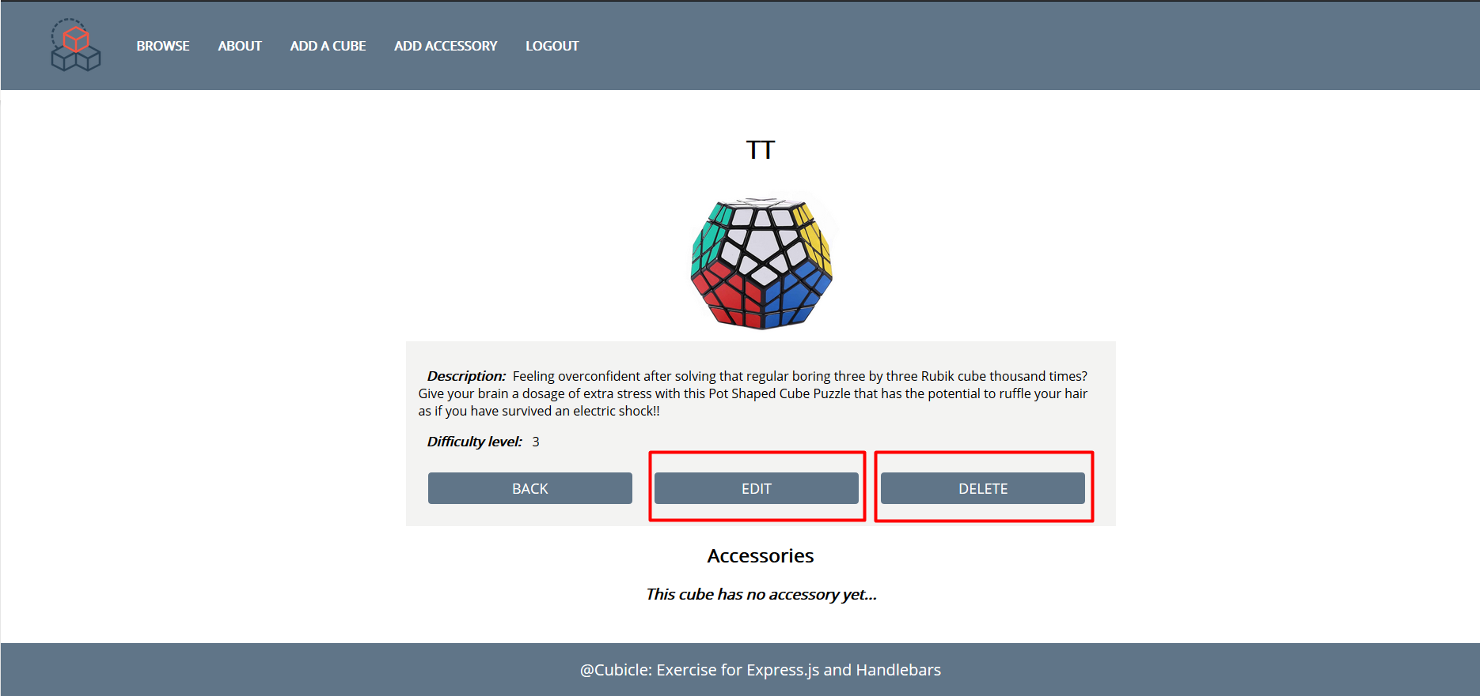

## Additional Pages

You should implement **4** new routes:

* **/login** - should render the login form
* **/register** - should render the register form
* **/edit** – should render the edit form
* **/delete** – should render the delete form

Make sure when you access /**edit** and /**delete** routes, they show the current cube information.

Use the provided [**RESOURCES**](http://svn.softuni.org/admin/svn/js-web/Sept-2019/JS-Back-End/05.%20JS-Back-End-Sessions-and-Authentication/05.%20Sessions-and-Authentication-Workshop-Resources.zip) to create the additional templates using Handlebars (Use **username: student**, **password: student** credentials to do that). Identify the dynamic parts and use appropriate syntax for interpolating and rendering the application context. Replace the old **CSS** file with the given one.

### Login Page

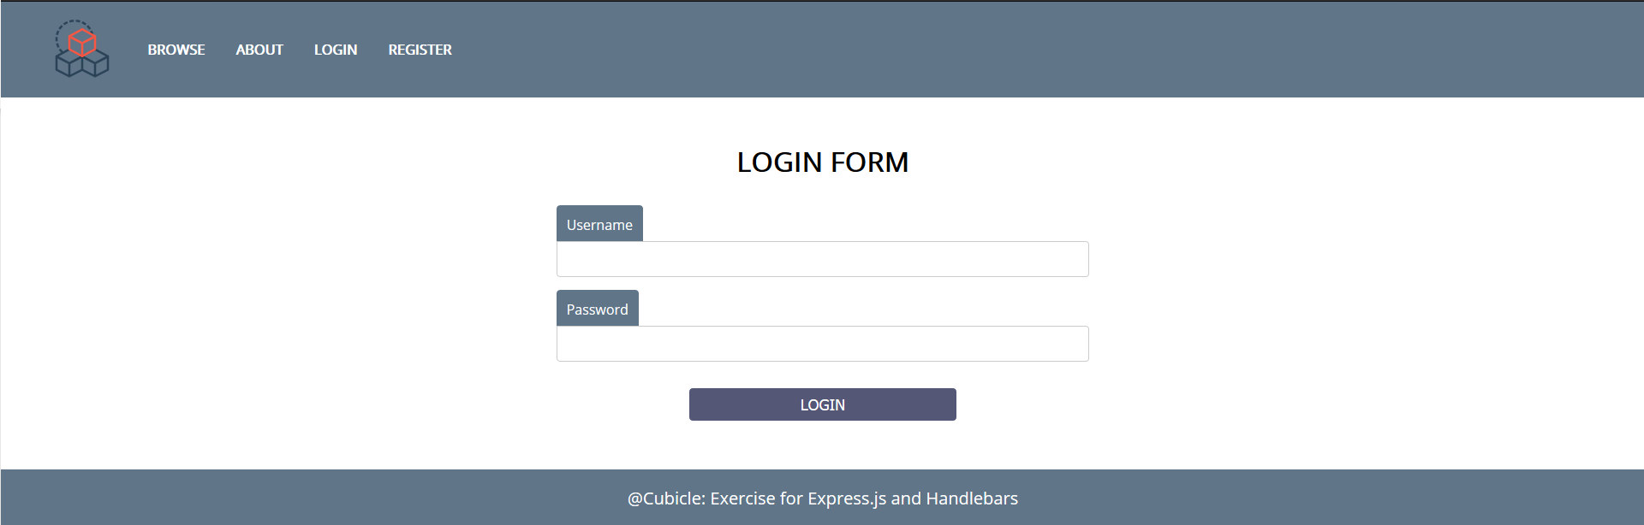

Register Page

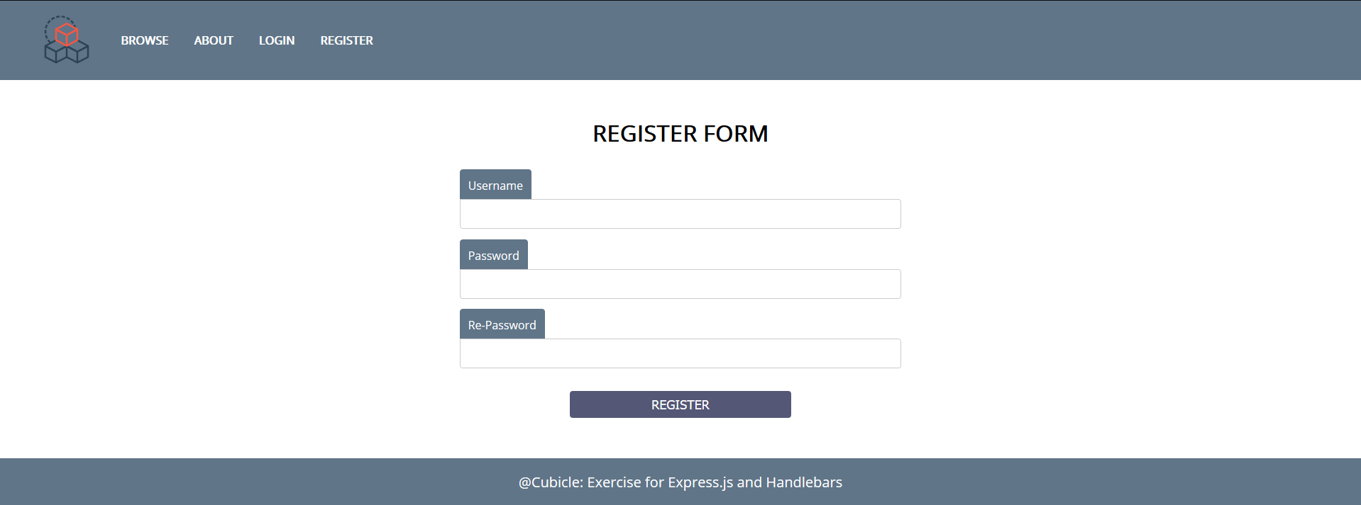

### Edit Cube Page

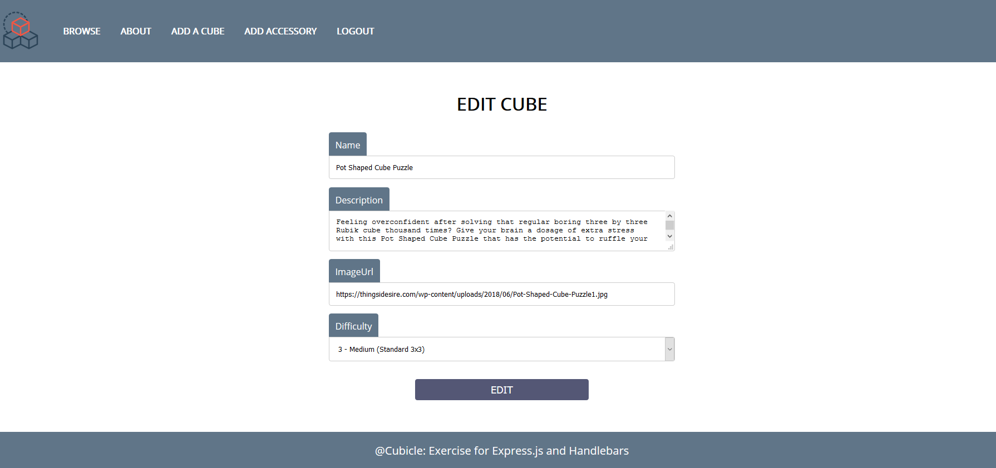

### Delete Cube Page

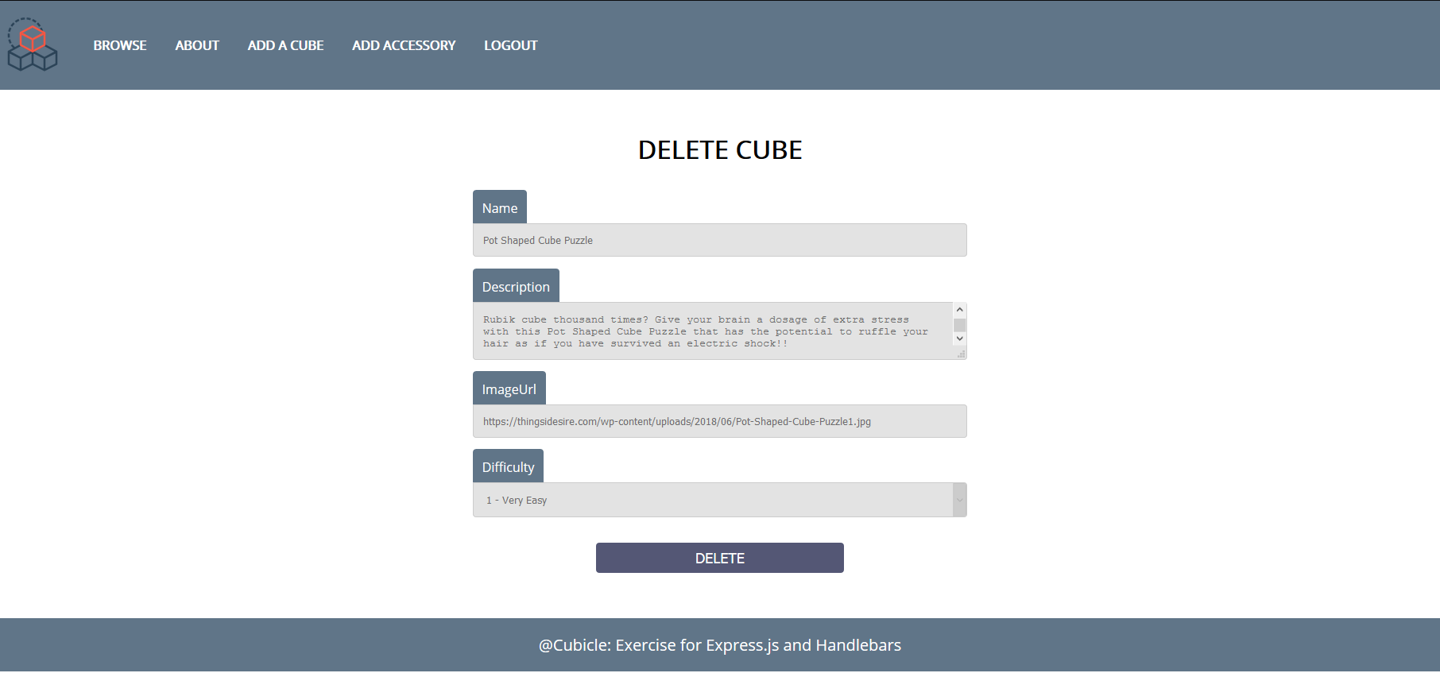

**Good Luck! 😊**